**PERFORMANCE TESTING**

Website: [**http://167.71.226.96/**](http://167.71.226.96/)

__________________________________________________________________

We are performing different test cases on the web page in JMeter by giving different values to Thread

User, Ramp-up Period and Loop Count.

**Sampler:** HTTP Request

**Server Name or IP:** http://167.71.226.96/

**HTTP Request:** GET

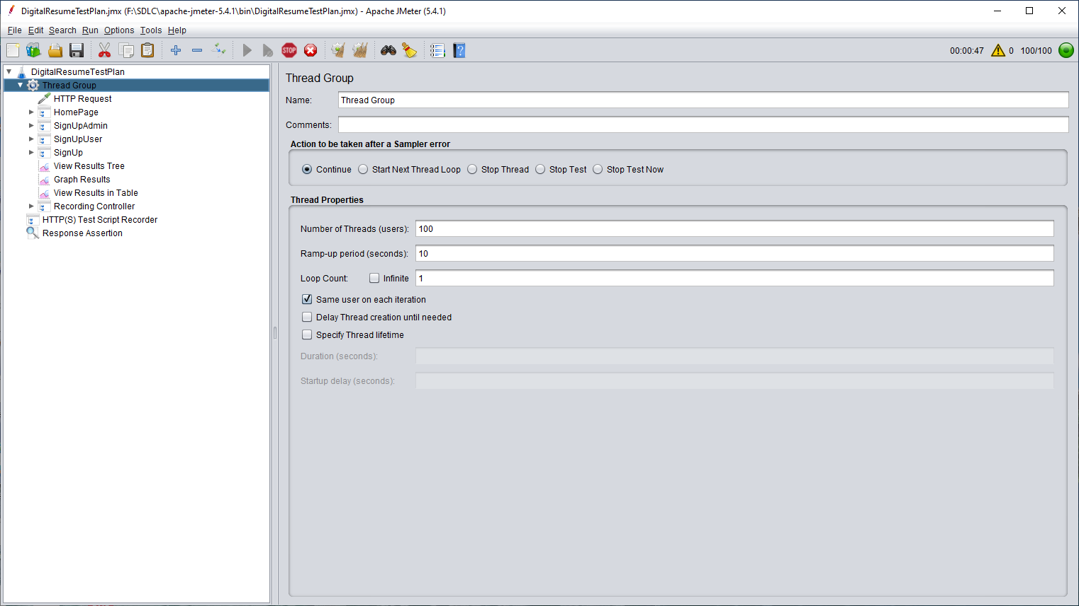

**The Sampler we are using to perform this testing are:**

• View Results Tree

• View Results in Table

• Graph Results

**Test Case : 1**

Thread Count : 100

Ramp-up Period:10

No of count : 1

There will be 100 samplers as we have given 100 Threads and Ramp-up Period as 10 with means

within 1 seconds the 100 users will be ramped up and loop count was set to zero

**Tree Result :**

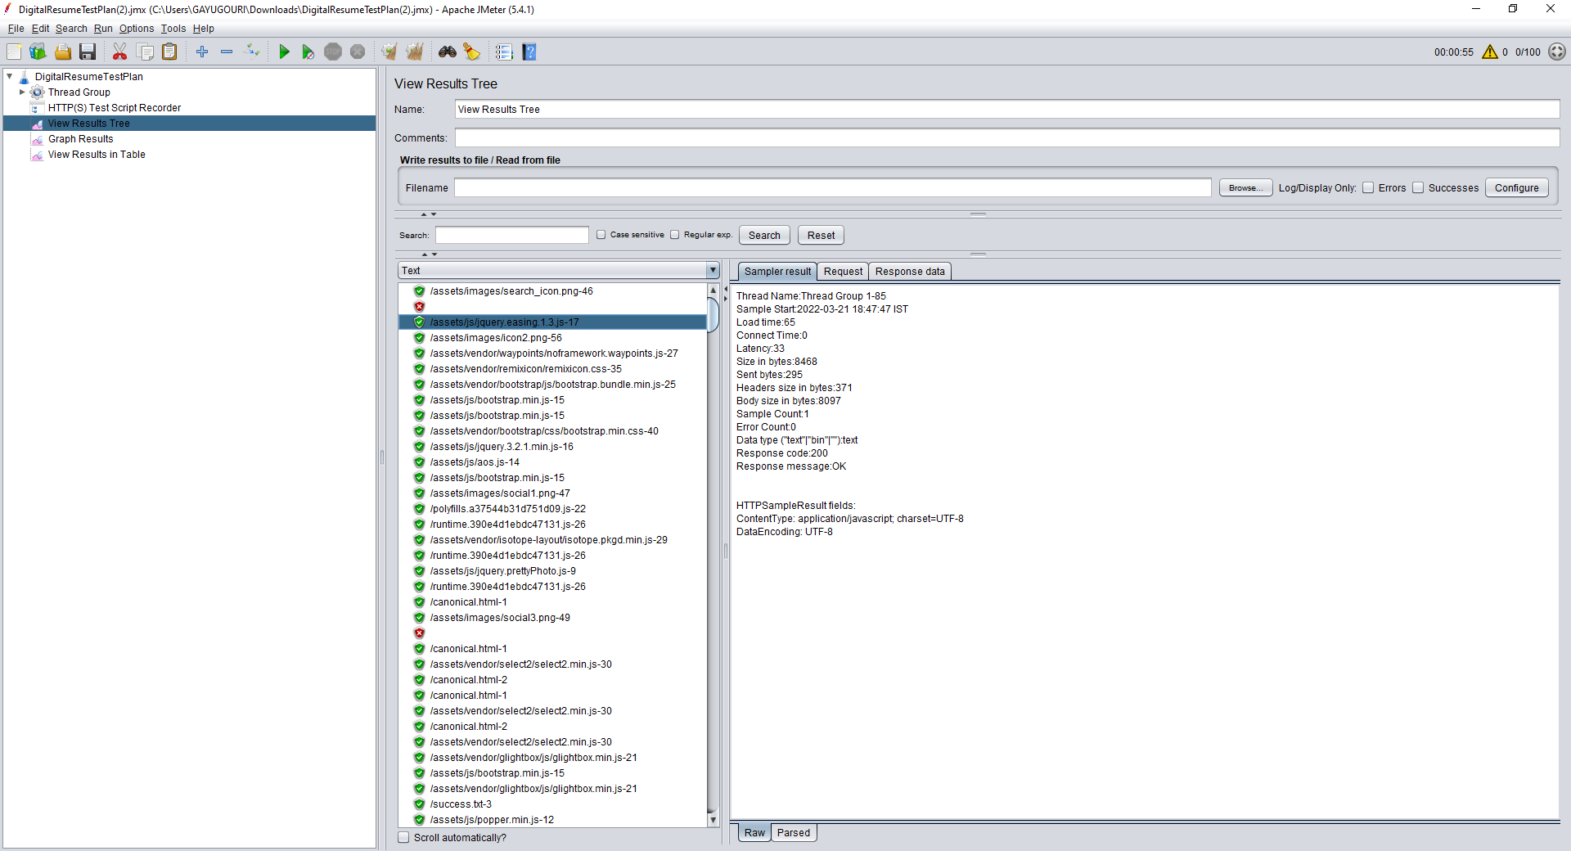

**Graph Result :**

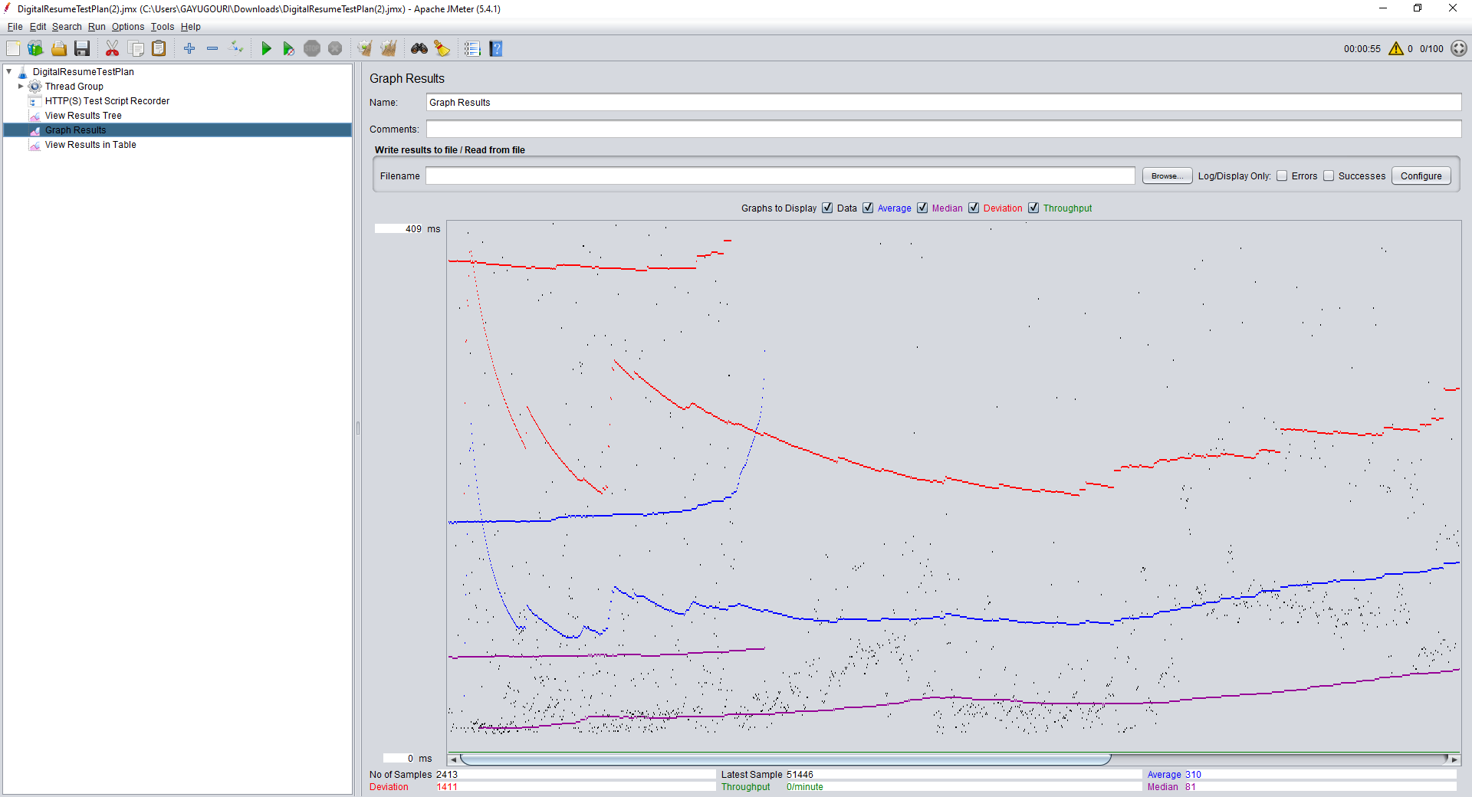

This will give the details of:

Number of Sample (BLACK): Number of users per request

Average (BLUE): It is the average time taken by all the samples to execute specific label.

Deviation (RED): Deviation is a measure of how response time is spread out around the Mean.

The smaller the Standard Deviation, the more consistent the response time will be.

Throughput (GREEN): Throughput is the number of transactions produced over time during a test.

It's also expressed as the amount of capacity that a website or application can handle.

Throughput = Number of request /number of time

Median (PURPLE): Number which divides the samples into two equal halves.

Half of the samples are smaller than the median, and half are larger.

Median should be close to average elapsed response time.

**Table Result :**

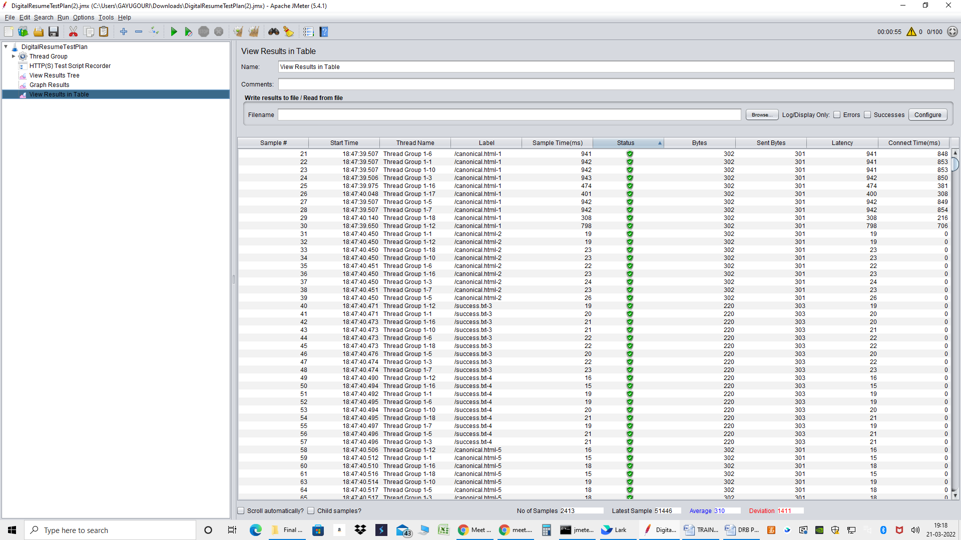

**Test Case : 2**

Thread Count : 150

Ramp-up Period:1

No of count : 1

There will be 150 samplers as we have given 150 Threads and Ramp-up Period as 1 with means

within 1 seconds the 150 users will be ramped up and loop count was set to zero

**Tree Result :**

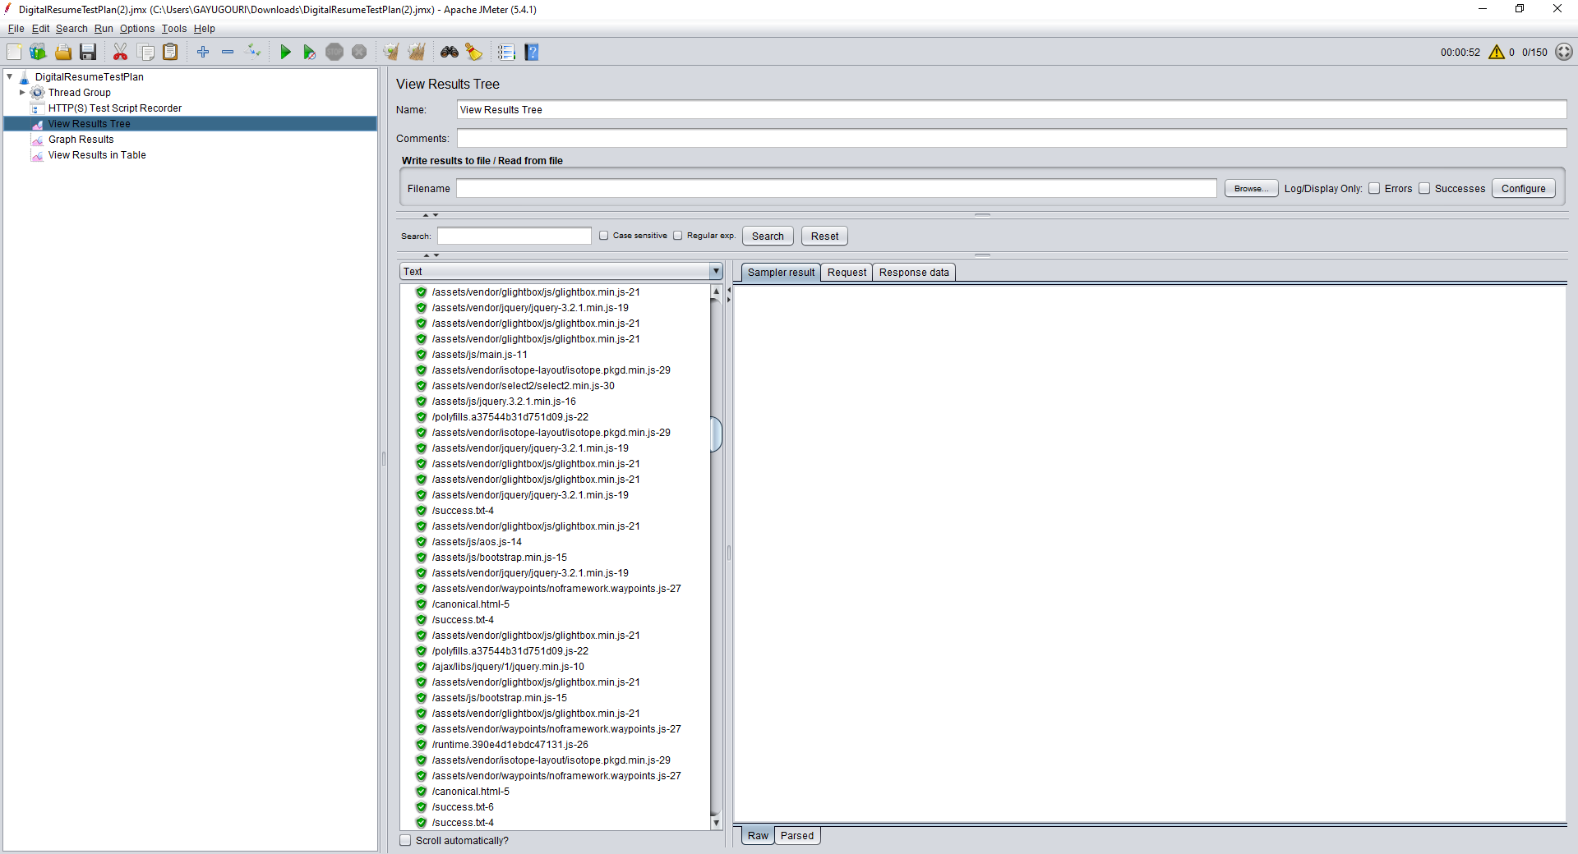

**Graph Result :**

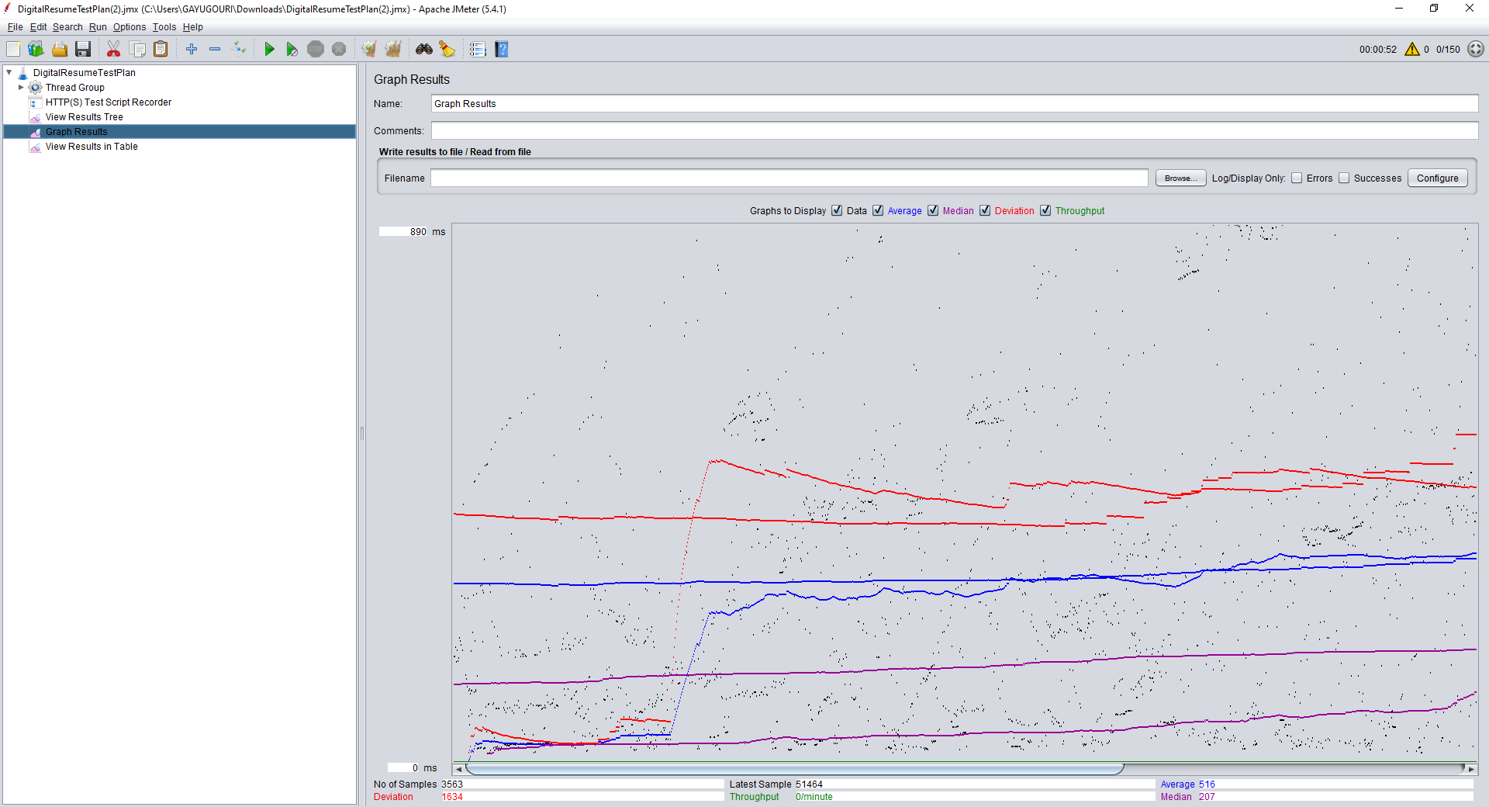

**Table Result :**

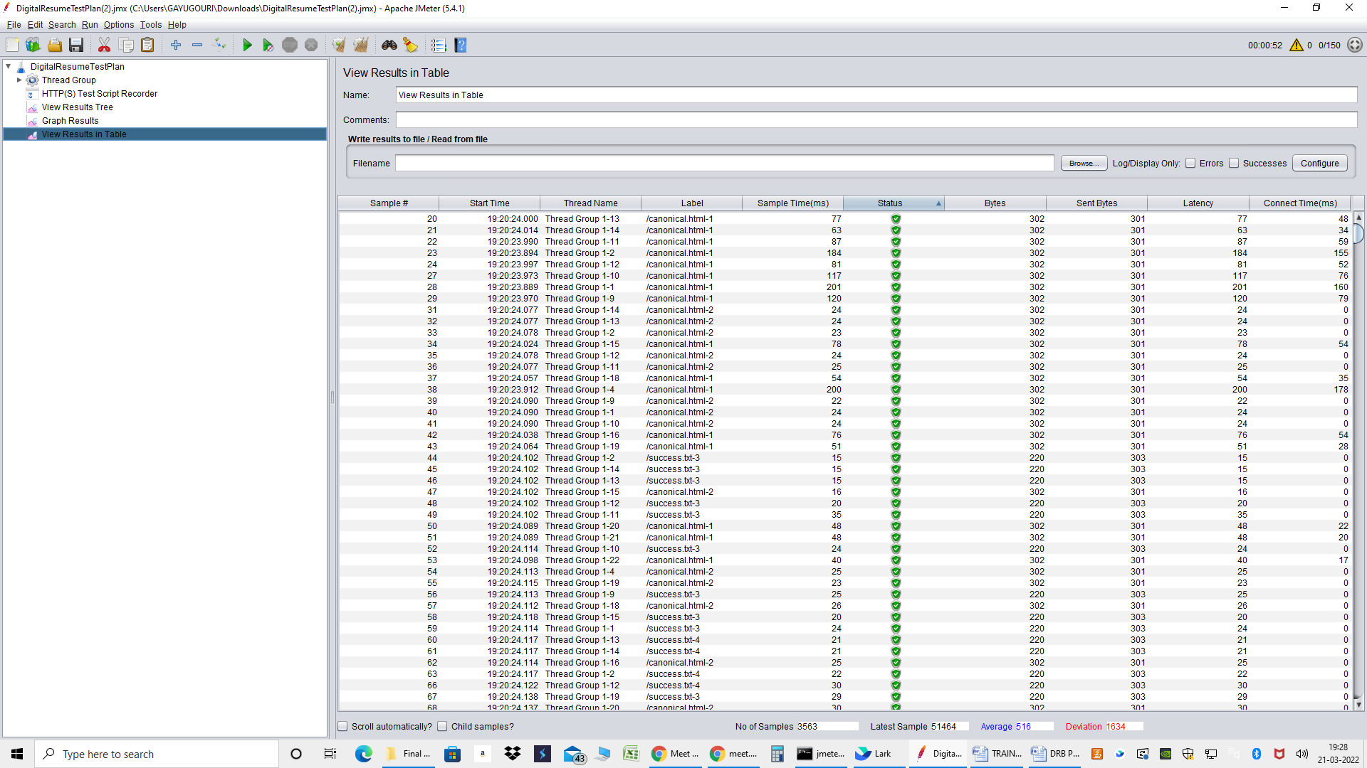

**Test Case 3 :**

Thread Count : 300

Ramp-up Period:10

No of count : 1

There will be 300 samplers as we have given 300 Threads and Ramp-up Period as 10 with means

within 1 seconds the 300 users will be ramped up and loop count was set to zero

**Tree Result :**

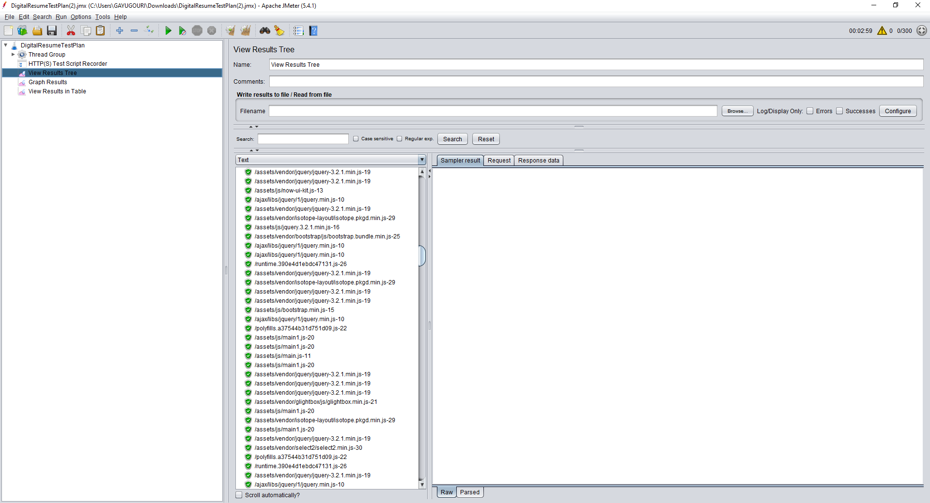

**Graph Result :**

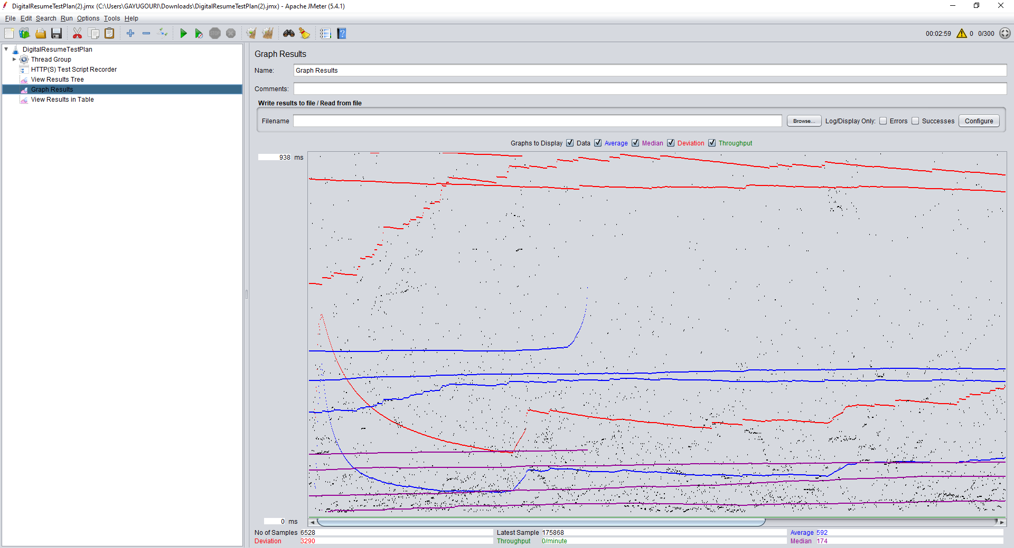

**Table Result :**

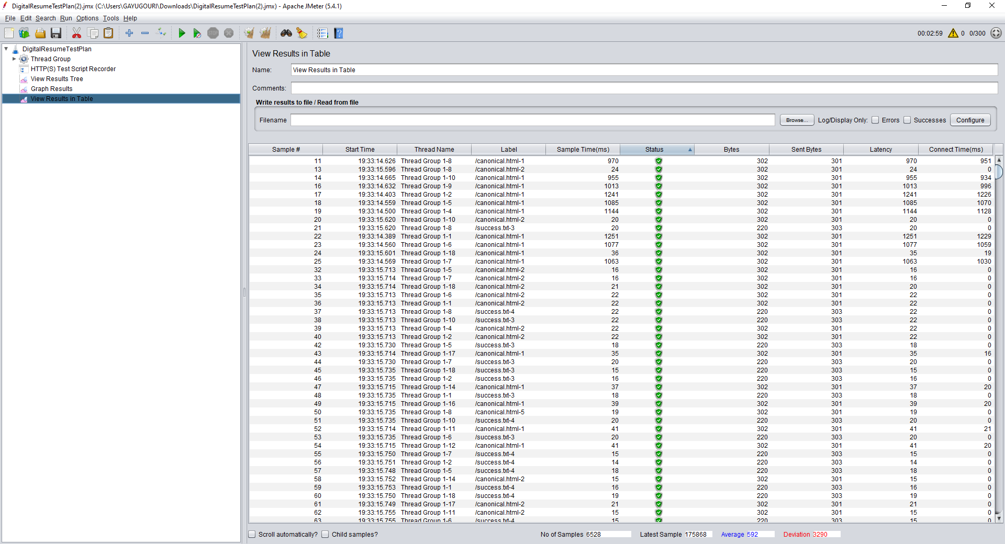

**Test Case 4 :**

Thread Count : 500

Ramp-up Period:10

No of count : 1

There will be 500 samplers as we have given 500 Threads and Ramp-up Period as 10 with means

within 1 seconds the 500 users will be ramped up and loop count was set to zero

**Tree Result :**

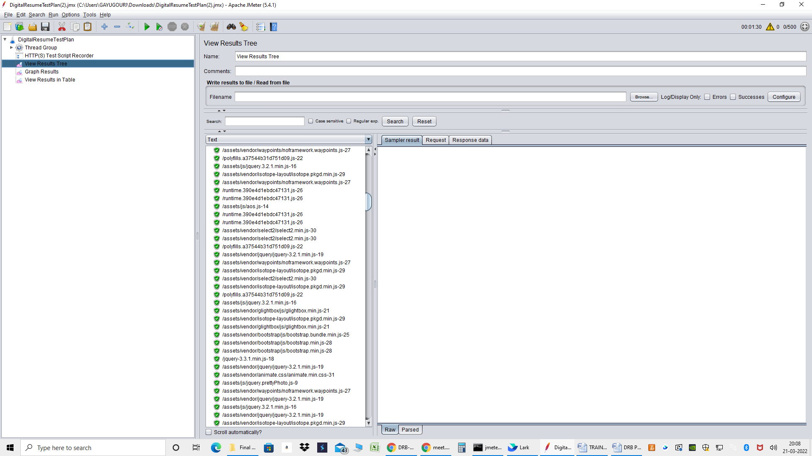

**Graph Result :**

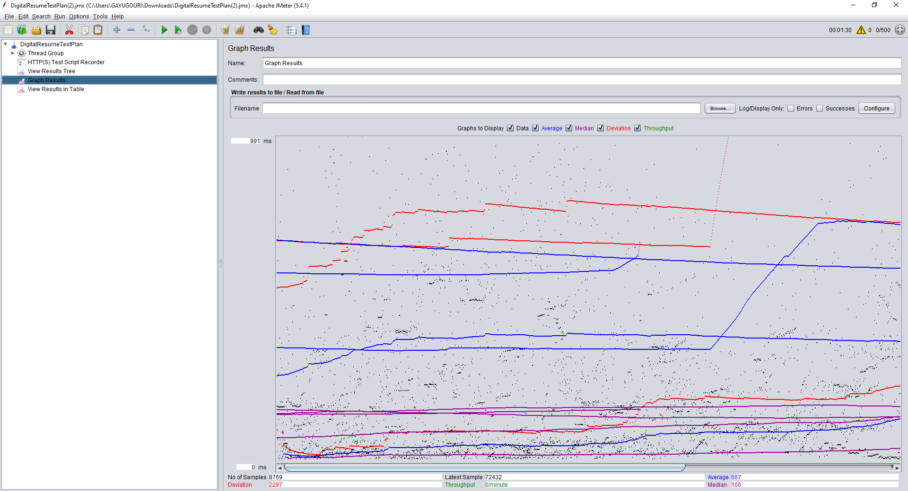

**Table Result :**

